**M.S.SANJAY**

**15BCE0517**

**MICROPROCESSOR AND INTERFACING-Lab Experiment 2**

**Code:**

1. Addition

.model small

.stack 64

.data

.code

start: mov ax,@data

mov ds,ax

mov al,04h

mov bl,06h

add al,bl

mov si,3000h

mov [si],al

mov ah,4ch

int 21h

end start

end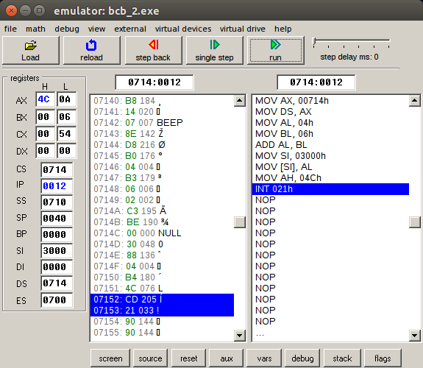

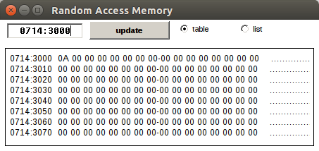

2. Subtraction

.model small

.stack 64

.data

.code

start: mov ax,@data

mov ds,ax

mov al,04h

mov bl,06h

sub al,bl

mov si,3000h

mov [si],al

mov ah,4ch

int 21h

end start

end

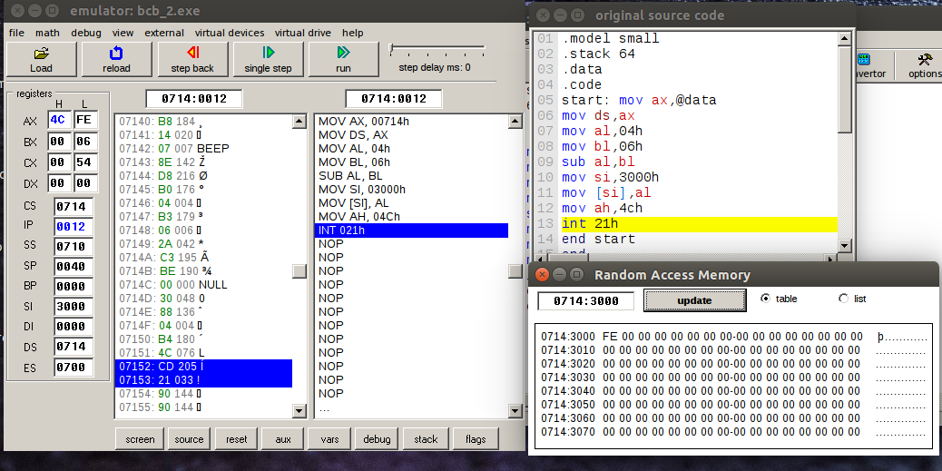

3. Multiplication

.model small

.stack 64

.data

.code

start: mov ax,@data

mov ds,ax

mov al,04h

mov bl,06h

mul bl

mov si,3000h

mov [si],al

mov ah,4ch

int 21h

end start

end

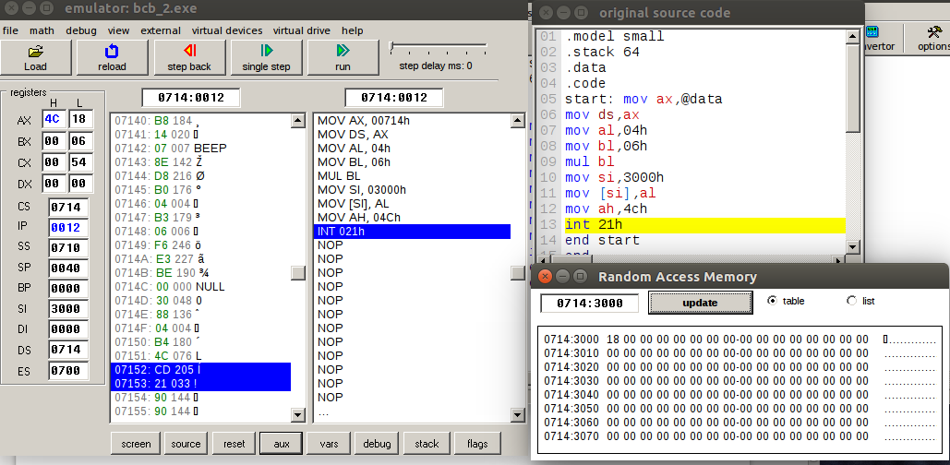

4. Division

.model small

.stack 64

.data

.code

start: mov ax,@data

mov ds,ax

mov al,04h

mov bl,02h

mov ah,0h

div bl

mov si,3000h

mov [si],al

mov ah,4ch

int 21h

end start

end

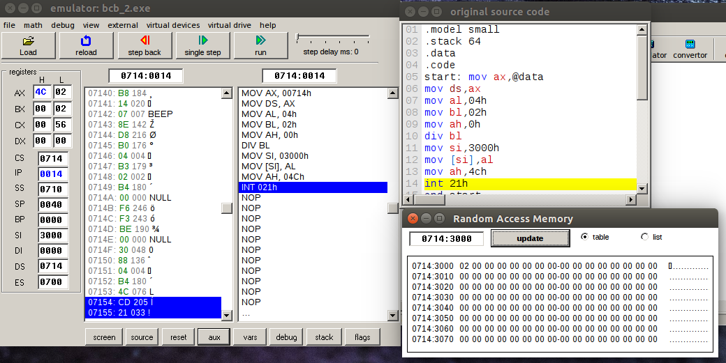

5. Carry

.model small

.stack 64

.data

.code

start: mov ax,@data

mov ds,ax

mov al,0ffh

mov bl,0ffh

one:

add al,bl

JC one

mov si,3000h

mov [si],ax

mov 3001h,01h

mov ah,4ch

int 21h

end start

end

